<https://public.tableau.com/profile/janis5126#!/vizhome/affordableRentDemographics/affordableRentDemographics?publish=yes>

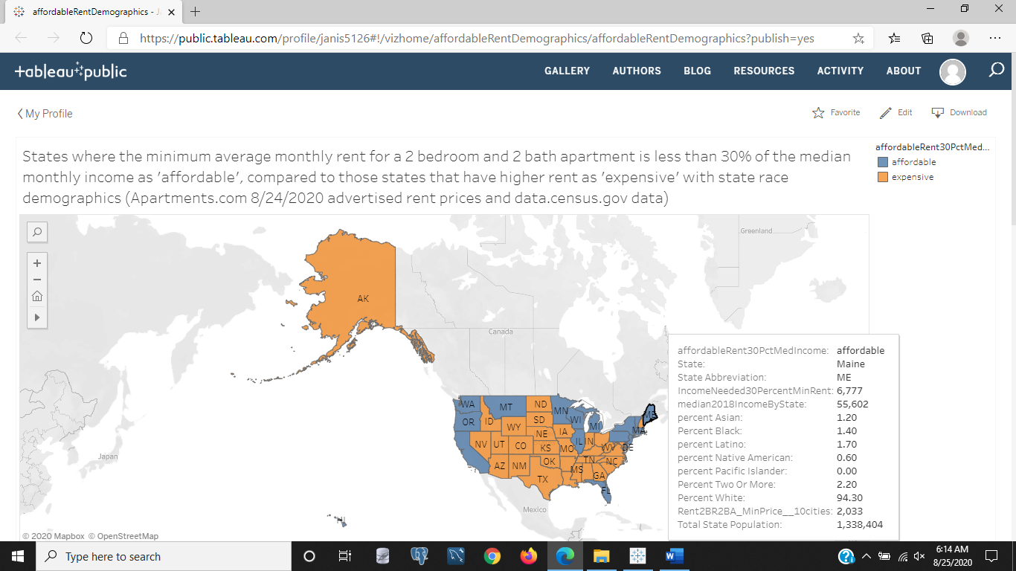

Figure 1: States where the minimum average monthly rent for a 2 bedroom and 2 bath apartment is less than 30% of the median monthly income as 'affordable', compared to those states that have higher rent as 'expensive' with state race demographics (Apartments.com 8/24/2020 advertised rent prices and data.census.gov data). The above chart is a comparison of those states that are affordable because they follow the rental guidelines for how much of your monthly income should be spent on rent or mortgage. But that guideline doesn't allow households to live comfortably because it is only 30% of your income, when we know many jobs don't pay the $5000-9000 a month that a $1500-3000 a month rental costs. We can see that the blue states are the expensive states and the orange states are the 'affordable' states. This used data from August 24, 2020 Apartments.com rental prices for pet friendly, two bedroom and two bathroom apartments in the 10 most populated cities in each state. Hovering over each state will give you the race demographics of the total population of each state using 2018 census data they forecasted for 2020. We can see that Maine is an expensive state because to rent their average minimum listed rent at 30% of one's income, a person would need to make $6,777 a month. Also, the percent of white people is 94.3% to a total population of 1,338,404 people. The next highest race distribution is Latino with 1.7% of the population for Maine.

<https://public.tableau.com/profile/janis5126#!/vizhome/affordableRentBusinessListings/affordableRentBusinessListings?publish=yes>

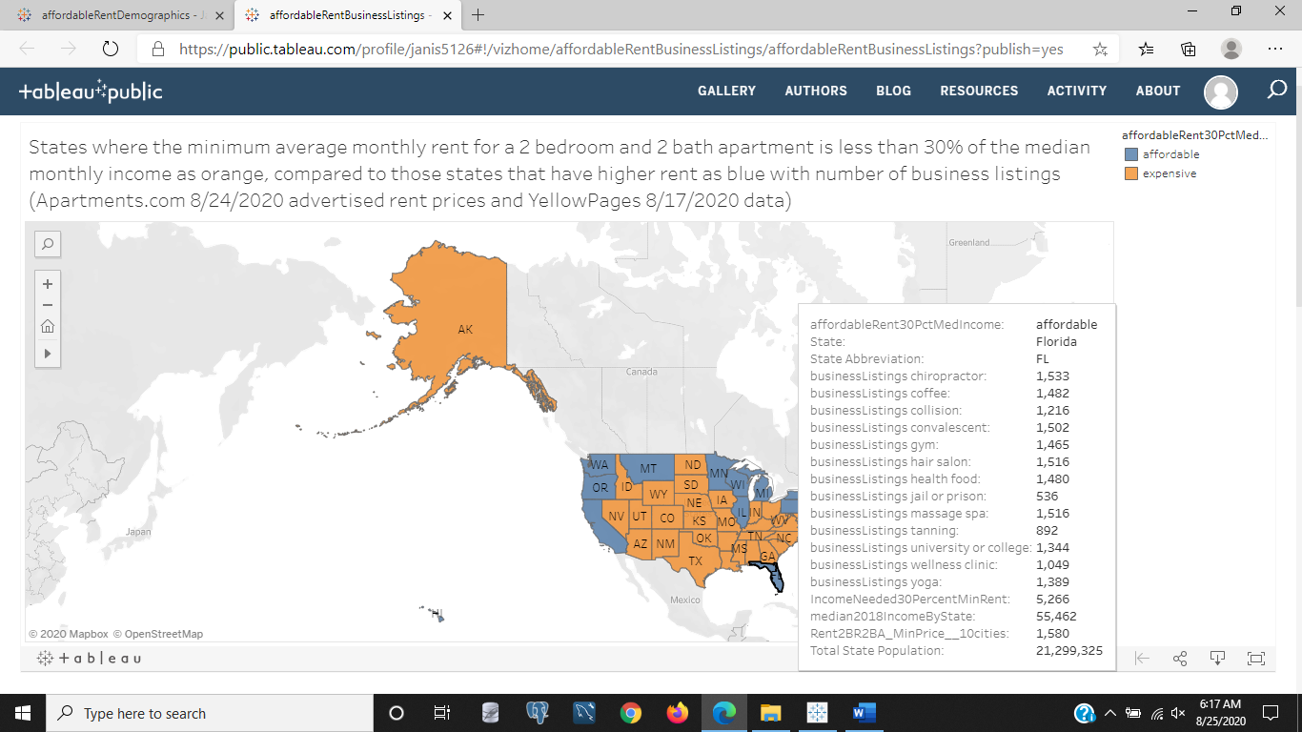

Figure 2: States where the minimum average monthly rent for a 2 bedroom and 2 bath apartment is less than 30% of the median monthly income as orange, compared to those states that have higher rent as blue with number of business listings (Apartments.com 8/24/2020 advertised rent prices and YellowPages 8/17/2020 data). Our map above is also a map of those states that are expensive (blue) to those that are affordable (orange), but with the number of businesses listed in the 10 most populated cities of each state and only specific businesses like chiropractor, coffee, collision, convalescent, gyms, hair salons, health food, jails, massage spas, tanning, universities, wellness clinics, and yoga. Expensive rent is defined here as having the average minimum listed rental price for a two bedroom and two bathroom apartment cost more than 30% of the median income for the state. We can see in Florida the details as it is the state being hovered on in the chart this image links to outside of this site. Florida requires $5,266 to afford a $1,580 apartment where the median income is $55,462 a year, the population in Florida is 21,299,325 people and there are 536 jails or jail related businesses. There are also 1,344 colleges or university related businesses.

<https://public.tableau.com/profile/janis5126#!/vizhome/populationJobsListedState/populationJobsListedState?publish=yes>

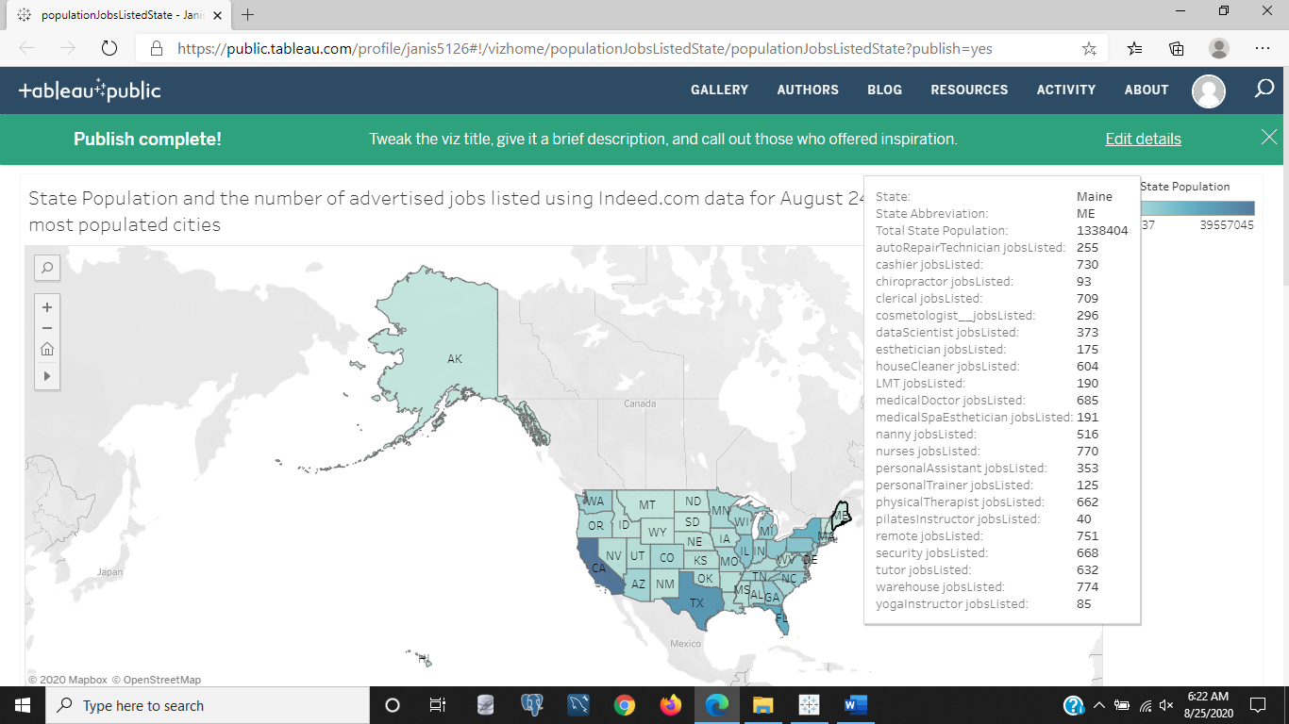

Figure 3: State Population and the number of advertised jobs listed using Indeed.com data for August 24, 2020 by each state's 10 most populated cities.In the above image the states are color gradient coded for population of each state. The darker states have the most people and the lightest states have the fewest people. The number of advertised jobs on August 24, 2020 is shown in each state for cashiers, chiropractors, clerical, cosmetologists, data scientists, auto collision repair technicians, estheticians, house cleaners, massage therapists (LMT), medical doctors, med spa techs, nannys, personal assistants, personal trainers, physical therapists, pilates instructors, remote or work from home jobs, security, tutor, warehouse, and yoga instructors. Maine is the state being shown its details. We see that Maine is a smaller state with 1,338,404 people compared to our larger populated states like California, Texas, and Florida. There are a lot more healthcare professional jobs like nurses, medical doctors, and physical therapists than there are health and beauty or wellness center jobs like chiropractors, massage therapists, estheticians, and cosmetologists. But there are also more nanny and house cleaner jobs listed as two to three fold the amount of those health and wellness jobs, that indicates the households probably have both parents working or live a life of leisure or need assistance, like the aging and hospice.

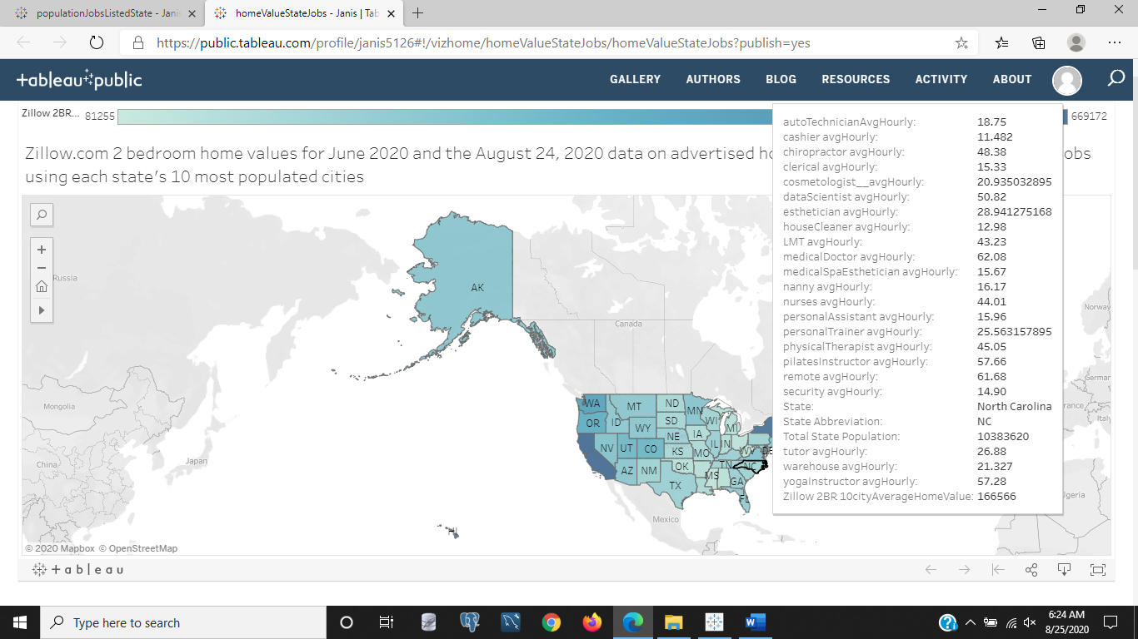

Figure 4: Zillow.com 2 bedroom home values for June 2020 and the August 24, 2020 data on advertised hourly pay on Indeed.com for selected jobs using each state's 10 most populated cities. In the above image, a chart that compares the average two bedroom home values for each state's 10 most populated cities is shown that is color coded from least expensive states as a light blue and the most expensive homes as dark blue. We can see California is an expensive state, but the state that we are looking at the details for is North Carolina. We can see the hourly advertised wages on August 24, 2020 from the 10 most populated cities of each state on Indeed.com for the following jobs: cashier, chiropractor, clerical, cosmetology, data science, esthetician, house cleaner, massage therapist (LMT), medical doctor, med spa tech, nurses, nannies, personal assistants, personal trainers, physical therapists, pilates instructors, remote or work from home, security, tutor, warehouse, and yoga instructors. We also see the state population as 10,383,620 people and the Zillow 10 city and two bedroom home value of $166,566.

<https://public.tableau.com/profile/janis5126#!/vizhome/medianIncomeStateHourlyJobs/medianIncomeStateHourlyJobs?publish=yes>

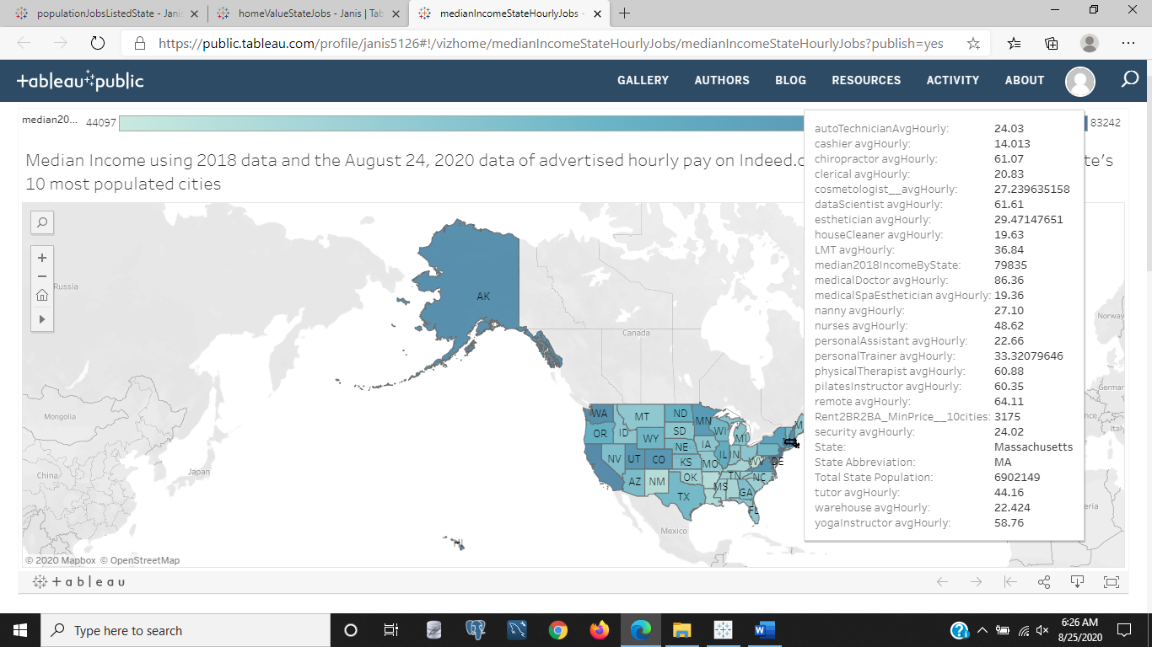

Figure 5: Median Income using 2018 data and the August 24, 2020 data of advertised hourly pay on Indeed.com for Selected jobs using each state's 10 most populated cities. The above image is to a chart it links to that shows the median income of each state with the lighter states having a lower median income and the darker states having a higher median income. The hourly wages is given for the following jobs: cashier, chiropractor, clerical, cosmetology, data science, esthetician, house cleaner, massage therapist (LMT), medical doctor, med spa tech, nurses, nannies, personal assistants, personal trainers, physical therapists, pilates instructors, remote or work from home, security, tutor, warehouse, and yoga instructors. The state of Massachusetts is shown with a population of 6,902,149 people and a median income of $79,835 and average minimum rent across 10 of the most populated cities in this state of $3,175. Harvard and MIT are universities in MA and not only are they well known and considered top tier schools, but they are also difficult to get into and expensive. Because any college is expensive in the US.